**Lab Report: 209L – 01 Ngyuen**

**Gene Drumheller**

**Experiment 5**

**Frequency Responses of Linear Active Circuits**

**Objectives:** To measure and calculate the frequency responses using an OP AMP.

**Equipment’s Used:**

* Oscilloscope
* AC Voltage Generator
* Multimeter
* Capacitor-Inductor Meter
* Clip leads
* BNC Cables
* 741 OP AMP
* Resistor (three 1kΩ)
* Capacitor (five 0.1µF)

**Prelab:**

Attached at end of the report.

**Lab:**

Measure your resistor and capacitor values:

Nominal value of each resistor = 1000.0Ω

Measured resistor value 1 = 993.0Ω

Measured resistor value 2 = 994.0Ω

Measured resistor value 3 = 983.0Ω

%difference = $\frac{Measured-Nominal}{Nominal} x 100 \%, R1= -0.7\%, R2= -0.6\%, R3= -1.7\%$

Nominal capacitor value 1 = 0.1nF

Nominal capacitor value 2 = 0.022nF

Measured capacitor values = 0.101nF

To create the value 0.022nF, we combined four 0.1nF capacitors in series to create 0.025nF.

%difference = $\frac{Measured-Nominal}{Nominal} x 100 \%, C1=1\%, C2=14.7\%$

Table 1: Measurement of tools

|  |  |  |  |
| --- | --- | --- | --- |
|  | Measured | Nominal | %difference |
| Resistor 1 | 993 Ω | 1000 Ω | -0.7% |
| Resistor 2 | 994 Ω | 1000 Ω | -0.6% |
| Resistor 3 | 983 Ω | 1000 Ω | -1.7% |
| Capacitor 1 | 0.101nF | 0.1nF | 1% |
| Capacitor 2 | 0.02525nF | 0.022nF | 14.7% |
|  |  |  |  |

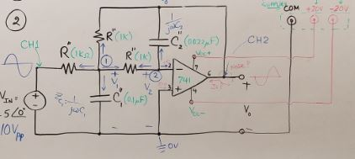

Figure 1: Circuit 1

Scaling used:

$$R_{0}={10}^{3}, W_{0}={10}^{4}$$

Original Value of Resistor = 1 ohm

Original Value of Capacitor 1 = 1F

Original Value of Capacitor 2 = 0.22F

With Scaling:

$$R_{1}*R_{0}=1*1000=1000Ω$$

$C_{1}*\frac{1}{R_{0}}*{\frac{1}{W}}_{0}=\frac{1}{1000* 10000}$ = 0.1nF

$C_{2}*\frac{1}{R_{0}}*{\frac{1}{W}}_{0}=\frac{0.22}{1000* 10000}$ = 0.022nF

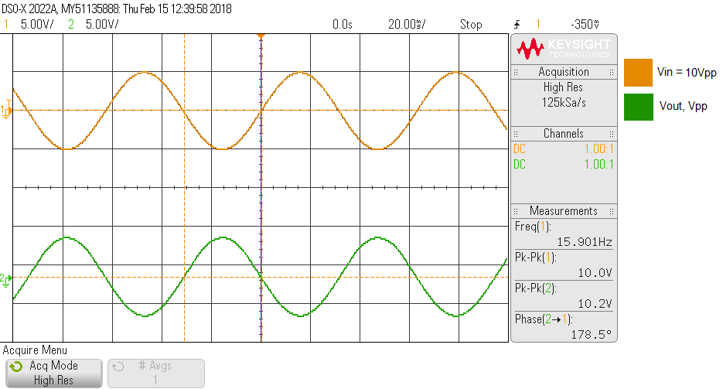

Graph 1: Measurements of Vin(t) and Vout(t) at F = 15.9 Hz

Vin(t) = 10.0Vpp, Vout(t) = 10.2Vpp, θ = 178.5°, Gain = 1.0

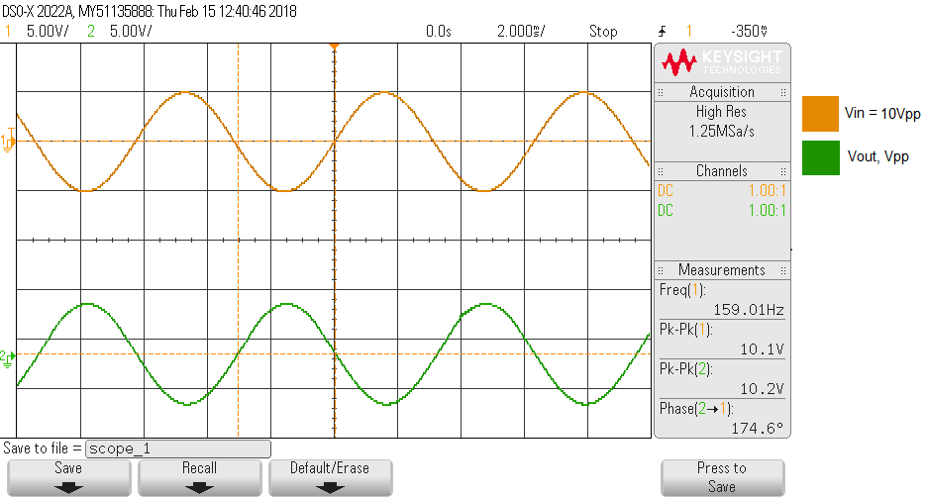

Graph 2: Measurements of Vin(t) and Vout(t) at F = 159 Hz

Vin(t) = 10.0Vpp, Vout(t) = 10.2Vpp, θ = 174.6°, Gain = 1.0

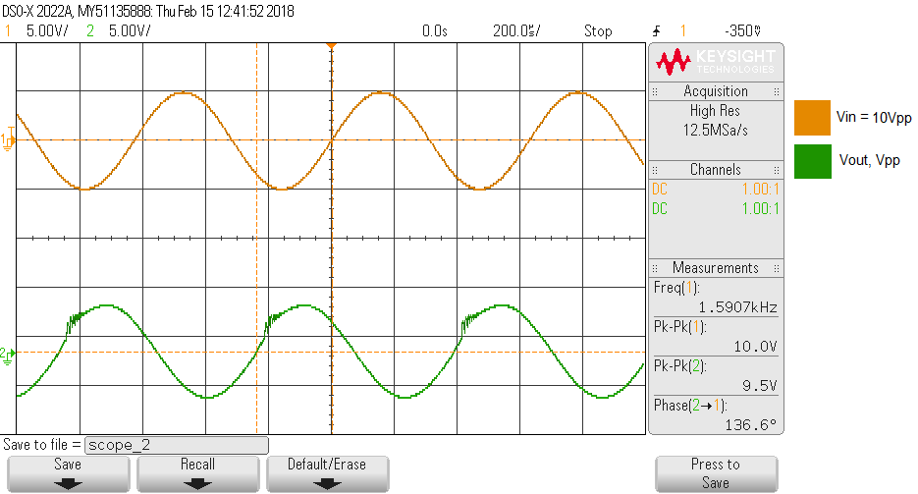

Graph 3: Measurements of Vin(t) and Vout(t) at F = 1590 Hz

Vin(t) = 10.0Vpp, Vout(t) = 9.5Vpp, θ = 136.6°, Gain = 0.95

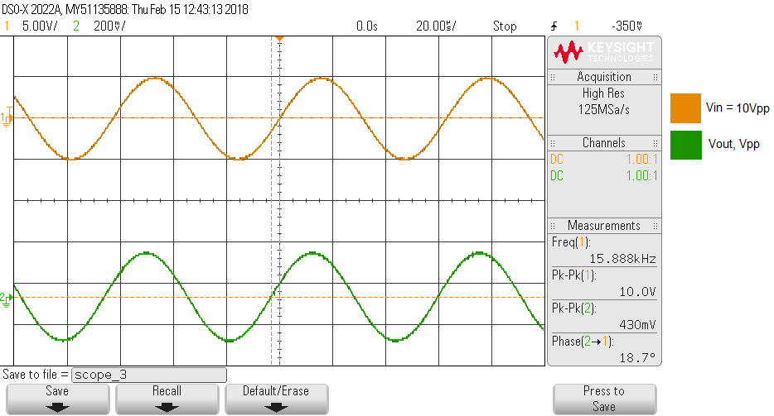

Graph 4: Measurements of Vin(t) and Vout(t) at F = 15900 Hz

Vin(t) = 10.0Vpp, Vout(t) = 0.43Vpp, θ = 18.7°, Gain = 0.043

**Note:** Graph of F = 159000 Hz and F = W3db = 3900 Hz unavailable. Forgot to take picture.

However, we did measure them, and write it down on our lab notes.

Additionally, we took the measurement of F = 5000 Hz and 6500 Hz to see the differences.

Table 2: Summary of the Measurements

|  |  |  |  |  |
| --- | --- | --- | --- | --- |
| Frequency | Vin | Vo | Phase | Gain |
| 15.9 Hz | 10 Vpp | 10.2Vpp | 178.5° | 1 |
| 159 Hz | 10 Vpp | 10.2Vpp | 174.6° | 1 |
| 1590 Hz | 10 Vpp | 9.5Vpp | 136.6° | 0.95 |
| 15900 Hz | 10 Vpp | 0.43Vpp | 18.7° | 0.043 |
| 159000 Hz | 10 Vpp | 0.0151Vpp | -23.5° | 0.00151 |
| 3900 Hz (3db) | 10 Vpp | 7.0 Vpp | 81.1° | 0.7 |
| 5000 Hz | 10 Vpp | 6.0 Vpp | 46.0° | 0.6 |
| 6500 Hz | 10 Vpp | 2.5 Vpp | 48.1° | 0.25 |

Graph 5: Plotting Frequency vs Gain

**Post Lab:** Attached at the end of lab.